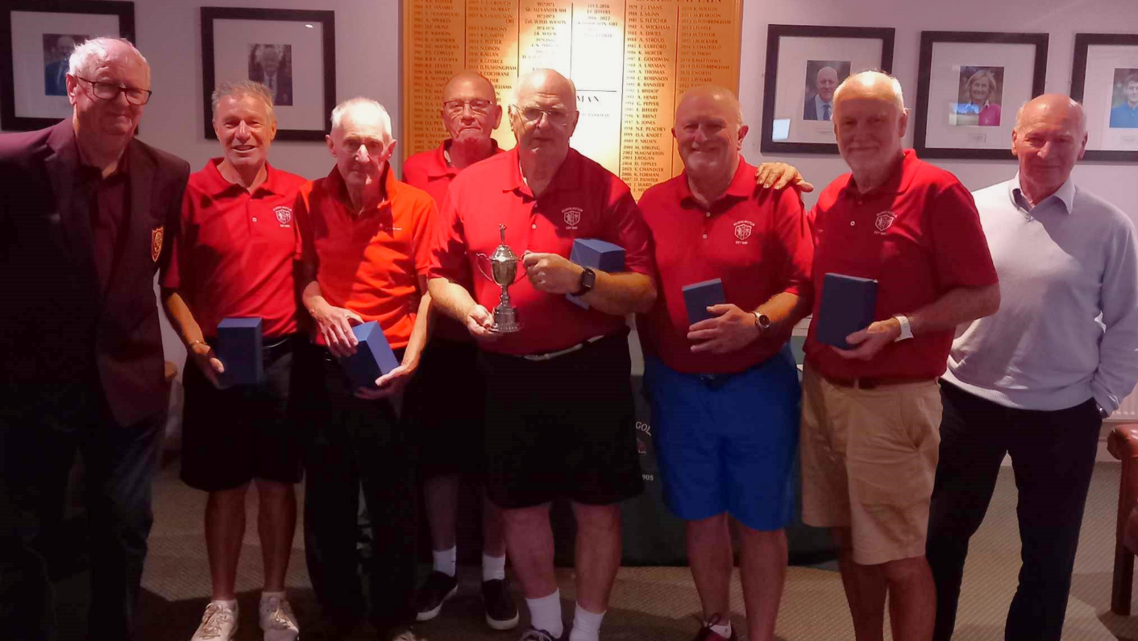
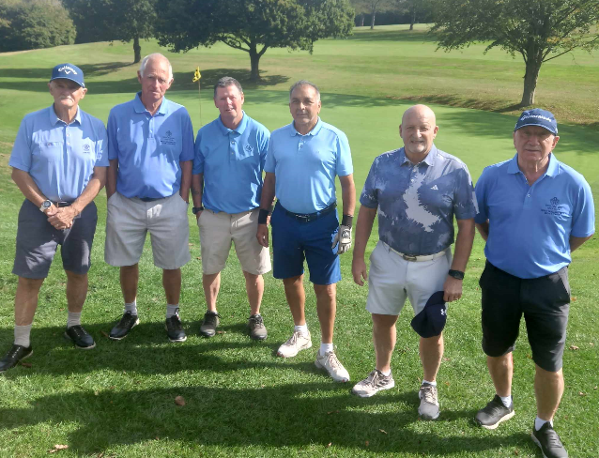
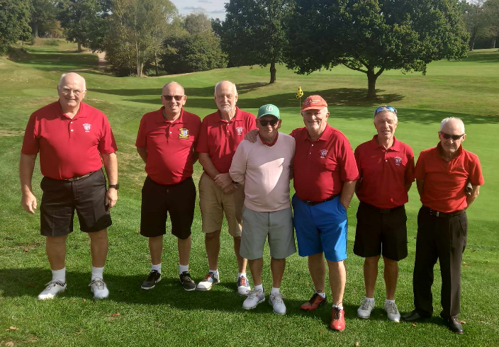
Bearsted team West Malling team
Tenterden President Ivo Fowle with winning Bearsted team and League Organiser John Crates
Bearsted team: David Stock (Captain), Phil Smith, Colin Tolman, Steve Ryan, Adrian Foster, Nic Brokenshire

