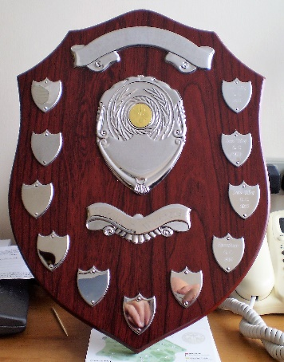**K.V.G.L Super Seniors (Group D) 2017**

|  |  |  |  |  |  |  |  |  |  |
| --- | --- | --- | --- | --- | --- | --- | --- | --- | --- |
|  | Home | | | | Away | | | | Total |
| Matches | | | | Matches | | | | Pts |
| Played | Won | Drawn | Lost | Played | Won | Drawn | Lost | Pts. |
| **Sene Valley** | 4 | 4 | 0 | 0 | 4 | 2 | 0 | 2 | 20 |
| Lydd | 4 | 4 | 0 | 0 | 4 | 1 | 1 | 2 | 18 |
| Cranbrook | 4 | 4 | 0 | 0 | 4 | 1 | 0 | 3 | 16 |
| Faversham | 4 | 2 | 1 | 1 | 4 | 0 | 1 | 3 | 9 |
| Walmer & Kingsdown | 4 | 0 | 1 | 3 | 4 | 0 | 0 | 4 | 1 |
| Points are awarded for Matches Won-Away (4) Home (3) Drawn Away (2) Home (1) | | | | | | | | | |

|  |  |  |  |  |  |  |  |
| --- | --- | --- | --- | --- | --- | --- | --- |
| **Kent Veteran Golfers League – Super Seniors – Group D – Fixtures and Results 2017** | | | | | | | |
| **Date** | **Home Club** | **Result…...** | **Away Club** | **Date** | **Home Club** | **Result…...** | **Away Club** |
| 26 Apr | Cranbrook | 4-1 | Sene Valley | 14 Jul | Walmer &Kingsdown | 2-3 | Cranbrook |
| 03 May | Walmer & Kingsdown | 0-5 | Sene Valley | 19 Jul | Cranbrook | 4-1 | Lydd |
| 9 May | Walmer & Kingsdown | 21/2-21/2 | Faversham | 25 Jul | Sene Valley | 41/2-1/2 | Lydd |
| 17 May | Sene Valley | 3-2 | Cranbrook | 31 Jul | Lydd | 4-1 | Cranbrook |
| 31 May | Faversham | 21/2-21/2 | Lydd | 02 Aug | Faversham | 41/2-1/2 | Walmer & Kingsdown |
| 06 Jun | Lydd | 4-1 | Sene Valley | 09 Aug | Lydd | 5-0 | Walmer & Kingsdown |
| 14 Jun | Cranbrook | 4-1 | Walmer & Kingsdown | 16 Aug | Sene Valley | 3-2 | Faversham |
| 19 Jun | Faversham | 11/2-31/2 | Sene Valley | 23 Aug | Faversham | 31/2-11/2 | Cranbrook |
| 20 Jun | Walmer & Kingsdown | 11/2-31/2 | Lydd | 04 Sept | Lydd | 3-2 | Faversham |
| 5 Jul | Cranbrook | 31/2-11/2 | Faversham | 05 Sept | Sene Valley | 5-0 | Walmer & Kingsdown |
| All Matches start at 12:30 for 13:30 Tee Off | | | | | | | |

|  |  |  |  |  |  |  |  |  |  |  |  |  |  |  |  |
| --- | --- | --- | --- | --- | --- | --- | --- | --- | --- | --- | --- | --- | --- | --- | --- |
| |  |  |  | | --- | --- | --- | | 2017 | K.V.G.L. Super Seniors | Venue | |  |  |  | | Wednesday 20th September | Group D – End of Season Event (Jamboree) | Lydd G.C. | | Thursday 19th October | All Group Winners – Final | Birchwood Park G.C. | | www.superseniorsgolf.weebly.com | | | |
| **The Group was formed in 2013 and for the 5 years it has been running Sene Valley Veterans have won the league on 4 occasions, they will now represent Group D in the Group Winners Final at Birchwood Park on Thursday 19th October 2017.**  Compiled and Edited by Colin Hatcher (Group D Organiser). |