Kent Golf Super Seniors League 2023 Grand Final at SHOOTERS HILL GC on Thurs 12 October 2023
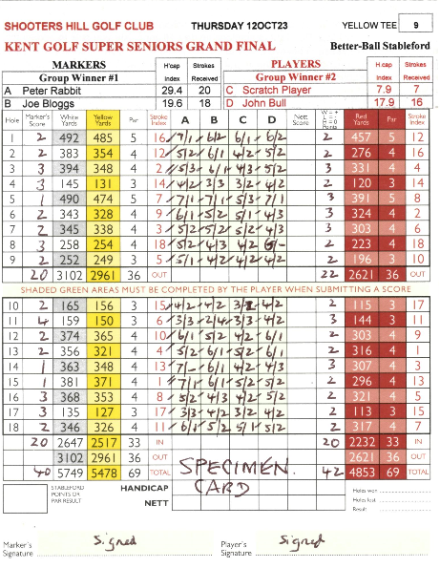
IMPORTANT REQUIREMENTS FOR ENTERING SCORECARDS
Scorecards for Better-Ball Stableford play require a different format from the Match Play or Individual Stroke Play cards with which players more accustomed. Past experience shows that Better-Ball cards are all too frequently entered incorrectly and severely risk disqualification. Accordingly each Player is strongly advised to read these guidelines.
For illustration, a Specimen Shooters Hill Grand Final scorecard is shown here.

Players will collect their card on Registration, but will exchange it with their drawn ‘opponent’ competitors on or before the first tee, so the card you are entering is for your PLAYER opponents and you are the MARKER.

It is suggested that you mark the holes where shots are to be allowed for each player. Remember you are not starting on the first hole.

After each hole has been played, your own Marker pair gross scores and stableford points should be entered in columns A & B, with the Better stableford points entered in the extreme left hand column ‘Marker’s Score’.
The two ‘opponent’ Player pair’s gross scores and stableford points are entered in columns C & D and their Better stableford points in the extreme right hand column ‘W.L.H Points’.
It is NOT essential to record both scores of each pair, as only the better stableford score counts, and the lower scoring player may not even complete the hole. (Needless to say NO putts may be conceded!) But in each case the better score MUST be attributed to the correct player.
In essence, you enter your ‘Marker’ pair scores first L to R and then your opponent ‘Player’ scores.

It is vital that the card you are marking mirrors the entries on your own card being marked by your ‘opponent’, and frequent cross-checks are recommended, and not just after 9 and 18 holes. There should be no discrepancies between cards.

At the end, both Better Ball stableford points columns need to be totalled and agreed. Both cards MUST be signed by both Marker and Player before they are handed in.

